Dillon Montana Geology

Alec Solberg

ESCI 390

Professor Nadja Insel

July 13, 2016

**Introduction**

Dillon Montana has many signs of historic geology in the area. The geologic time scale in this area ranges greatly from the Pennsylvanian to the Quaternary period. The main site of interest to be studied was the Block Mountain site in Dillon Montana because of certain incorporations of geologic mechanisms, topography, and rocks. The topography ranged from 5,100 feet to 5,600 feet. There were either gradual increases or decreases in elevation or certain spikes in low or high elevation. The study was done for two weeks and being out in the field took about seven hours. Rocks and structures in the layers of the site were investigated and analyzed. Strike and Dip as well as description of the layers were recorded in a journal. Pictures were taken to reinforce recording and evidence of the rock units. Strike and Dip was used to determine if a significant change in direction, dip angle, and dip direction of the rock units was occurring. Descriptions were recorded to see what the type of rock is and the formation it is a part of when being investigated after being out in the field site. The climate of this site is particularly very hot and sunny. Vegetation is composed of green shrubs and cacti. The Block Mountain site is a result of the two orogenies that occurred in the past when mountain building was occurring. Many of the layers are uplifted and show an interesting amount of layer thickness variation. Some beds show very low resistance to weathering while some others show very high resistance.

**Regional Geology**

Dillon, Montana is very abundant in many sedimentary strata and igneous intrusions. The minerals found in Dillon are feldspars, micas, chert, calcite, amphiboles, and quartz. There are volcanic intrusions known as dikes that have surfaced. The dikes are made up of granitic rock and basaltic rock. The till deposits are gravel sized grains scattered amongst the surface. There are different types of folding that are common around the area. Thrust faults make up most of the towering hills that are formed from these faults.

**Stratigraphy**

Pennsylvanian Period

Quadrant Formation

There are many scattered chert beds sticking out and easily scratched a knife. No grain size detection can be available for chert rocks. The rock had a yellowish tinge or sometimes a white tinge in the rock. The white tinge may have just been weathering on the rock. The texture of the rock was very greasy or slick to feel. The rock would break off into very sharp points every time it was struck by a rock hammer. There was no reaction to the HCl when it was applied to the rock.

Permian Period

Phosphoria Formation

No visible grains are visible in the rock. A glassy reflection comes off the rock. Sometimes the rock would show black bands in the rock. The rock was very difficult to break a piece off with a rock hammer. The hard impact that would hit the rock made a gunpowder odor. Quartzite is the leading result of these observations since it could also scratch a knife very easily.

Triassic Period

Dinwoody Formation

The grain sizes of the rock were very fine grained to fine grained sand size. There would be some calcite crystals of a size that was one millimeter big. The upper dinwoody had a more slaty type of shale while the lower dinwoody had more fissility in the shale. The fissile shale broke off into very thin sections. Since these are shales and require a quiet environment to be deposited, the sorting must be poorly sorted. Some corals would be found in the rock that feathered out in tiny stems. The upper dinwoody had a dirty bright red type of weathering on the surface of the rock. The lower dinwoody had a dark grayish type of weathering on the surface.

Jurassic Period

Morrison Formation

The rocks were heavily and easily eroded at the surface. This made it rare for the formation to show throughout the site. When it was seen you would see very fine grained rocks where you could not see the grains with a hand lens. The color was always a dark green and broke off easily into chunks with the hammer, but did not break off easily with hands. It also reacted with the HCl, confirming it to be a mudstone.

Cretaceous Period

Kootenai Formation

Lower Clastic Member

The base of the member is composed of a conglomerate that has chert grains ranging from one centimeter to seven inches in diameter. The sorting for the conglomerate was very poorly sorted throughout the rock. Beyond the base is a red sandstone layer made mostly of red feldspar and some quartz grains that was well sorted. A texture called “salt and pepper” which consists of black and white quartz grains in a rock belongs to the salt and pepper sandstone. The salt and pepper sandstone has green moss growing on the surface and brownish red weathering on the surface of the rock, which was moderately well sorted.

Middle Limestone Member

A thin layering of dolostone was in a two to three foot sized bed. The rock would only fizz when powdered and wouldn’t fizz if put directly on rock without scratching it. There was yellow weathering on the surface of the rock. Limestone with a micritic texture was seen where no visible grains were obvious to the naked eye.

Upper Clastic Member

An interchangeable layering between conglomerate and green siltstone was easily noticeable in the field. The conglomerate had smaller grains in size and size range. The sorting was poorly sorted in the conglomerate. The grain size range is only about two millimeters to one centimeter in diameter. The siltstone was very fine grained and the green color was consistent throughout the rock maybe due to impurities in the rock. Since the rock is a siltstone, it is classified as being poorly sorted because silt requires low energy environments to be deposited. The salt and pepper sandstone appears again except it has lots of cross bedding involved in this layer. The sorting of the sandstone was well sorted.

Gastropod Limestone

The limestone ranged from fine grained to medium coarse grained with calcite veins in the rock. The sorting was poorly sorted due to some increases in grain size. There were also patches of three millimeter calcite crystals. Sometimes when the rock was very black and was smelled, it had a petro smell on it. Gastropods support the rock with a mud matrix. This can be classified as a pack stone according to (Dunham, 1962). There are also calcium carbonate crystals grown into the gastropod shells. Constant amounts of miniature folds in the layer appear along the bed.

Blackleaf Formation

Flood Member

Yellow weathering on the surface of bed is constant throughout the layer. Dark red weathering appears further south of the block mountain map past the road. The layering is very blocky, thick, and contains some rare amounts of black bands in the rock. The effervescence is not strong and only reacts between the grains suggesting very little calcite cement. The rock contains fine silt sized grains throughout the rock indicating a poorly sorted texture and some calcite veins were found. The rock has a grey color and is determined to be a siltstone.

Vaughn Member

There were contacts seen, but no rocks available for identification.

Felsic Intrusive Rocks

An igneous intrusion showing itself at the surface shows an even mix of quartz, muscovite, potassium feldspar, and biotite exist in the rock with trace amounts of hornblende. The grains are all very coarse grained and contain mostly felsic minerals. This fully supports the rock to be granite.

Quaternary Period

Alluvium Formation

Most of the rocks come in a huge variety of sandstones on the ground with sub angular minerals also being on the ground. This is very poorly sorted material because of the randomness of grain sizes and boulders lying around. Some of the minerals were potassium feldspar, chert, or quartz. The gravel sized minerals were scattered throughout the ground because of drop off from glacial activity and then erosion of rocks.

**Structures**

There are two anticlines and one syncline on the map, most of which have some part of it overturned. The Sandy Hollow anticline has an interesting type of anticline and is located towards the middle south of the site boundaries on the map. It is not a symmetrical anticline, but it is an asymmetrical anticline with an overturned limb. The anticline is not overturned, but the right limb of the gastropod limestone is overturned. The overturned gastropod limestone goes into an overturned syncline called the Buffalo Jump Syncline. The syncline is located furthest east of the sandy hollow anticline. The overturned syncline has the younger layers going toward the center. The reason this is an overturned syncline is that all the layers on both limbs are dipping in the same direction. The Ziegler anticline is an overturned anticline because all of the layers are dipping in the same direction. The overturned anticline does become cut off towards the right limbs of the anticline because of the fault moving towards the Sandy Hollow anticline. The anticlines and syncline are being overturned mostly due to the low angle faults in the area. These low angle faults are called thrust faults.

The only reason these could be thrust faults is that if the faults were indeed reverse faults that are faults greater than thirty degrees you would only see cut offs in the bedding, not as intense folding, and not significant changes in the dip direction of the beds. The two thrust faults reside west of the site on the map. The first thrust is called the Sandy Hollow thrust fault and is located where the Sandy Hollow anticline ends and the Ziegler anticline starts. The second thrust fault is called the Ziegler thrust fault and is located just after the Dinwoody formation ends in the Ziegler anticline. In a fault, the hanging wall is the moving block on the fault line and the footwall is the stationary block. The Phosphoria formation was where the hanging wall in the Sandy Hollow thrust fault is located. Ziegler thrust fault shows the hanging wall to be part of the Dinwoody Formation.

Many of these folds also show the direction of where the hanging walls and thrust faults were moving. When looking at the folds there is an easy recognition of folding being overturned toward the east. This means the faults and hanging walls were pushing towards the east. This pushing from the faults resulted in many deformations of the folds.

A nose in a fold is the top most part of the bed where the bed starts to descend or ascend back to where it started its ascension or descent. The noses in the Sandy Hollow anticline gradually become more and more overturned. The thicknesses become thicker in the nose as well. Sandy Hollow has weird deformation in the limbs on the other hand. From the Lower Dinwoody to the Morrison formation, there is thickening in the thicknesses of the beds on the right limb. Then from the Middle Limestone to the Lower Clastic member there is thinning of the beds thickness. The thinning of the beds is due to fold being in mid overturn sequence. What it means is that the fold was just starting to overturn and the beds on the outer most part of the fold were overturning leaving thin beds at that moment because not all of the beds overturned at once so there is thickening and thinning of these beds thicknesses.

**Geologic History**

When the Quadrant formation was made, there was lots of oceanic activity going on and there is evidence of this activity from the chert beds found. There was also sandstone that was found to be very well sorted and rounded. The chert bed supports an oceanic reef type of basin. The sandstone shows where the beach might have been at some point because that type of sandstone requires high amounts of energetic movement. The Phosphoria formation had the phosphorus smell in the quartz sandstone when struck with the hammer. Quartz sandstone isn’t a phosphorus type of rock, but animals can produce that kind of smell when they defecate. During the formation of the sandstone there was a mix of the phosphorus with it from fecal matter in the soil. This was a change in the timescale because the Quadrant sandstone did not have that smell in its bedding.

The Dinwoody formation has very little brachiopods, but does show an extinction event did happen sometime at this point. The shales in the Dinwoody show that the ocean environment was starting to calm down and the energetic movement was no longer fast paced. The Morrison formation has a mudstone bed because the water was no longer a quiet ocean. It was actually a fluvial environment now because mud can only deposit and resist fluvial flow at the same time. The Cretaceous period shows many changes in the sea activity because of the alternating types of beds in the stratigraphic members. The limestone beds show the lower energy movement of water while the sandstone beds show higher energy movement. The vertical succession of the layering starts from the shale limestone and moves to the mudstone, and then alternates between sandstone and limestone as you move up in the time scale. This shows a regression model of the sea.

The cross section doesn’t start to show major overturning and changes in thickness until the lower clastic member is seen. This is the result of the faulting, which means the faulting started to happen around the beginning of the cretaceous period. This occurred because of the Sevier Orogeny that occurred from the collision of the North American and Farallon plate, which made the thinly spaced out thrust faults. The thinly spaced out thrust faults are called thin skinned deformation. The extraordinary changes in thickness are a result of deposition while the thrust faulting was occurring. This resulted in weird depositional patterns of the layers.

The Laramide Orogeny came in shortly after the Sevier Orogeny around the end of the Mesozoic to the early Cenozoic. As the subduction of the plate increased further down from the Laramide Orogeny, it caused igneous intrusions to uplift such as Block Mountain. Other igneous rock bodies were protruded out onto the surface from hotspots beneath the crust like the felsic intrusive rocks. The granite dike that was found out in the field was part of the felsic intrusive rock formation. Activity of the subduction plate started to calm down and the glaciers from the ice age started to advance over the United States area. The advancing of the glaciers left boulders and gravel on the ground as they melted. These boulders and gravel were found in the middle and southern most part of the field site. This ended the geologic activity and timescale of the Dillon, Montana area.

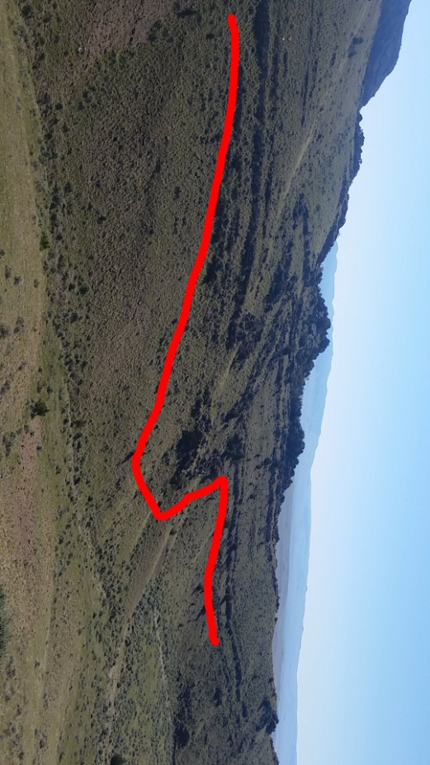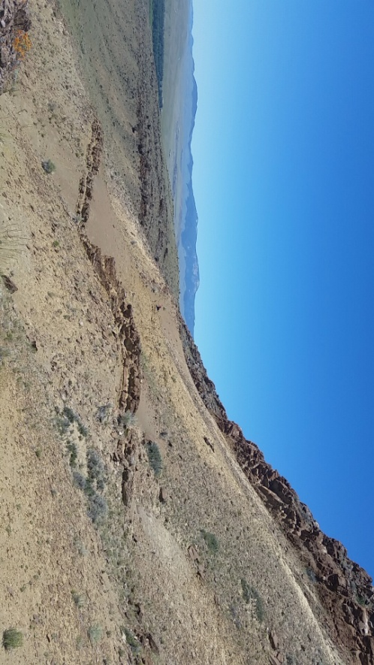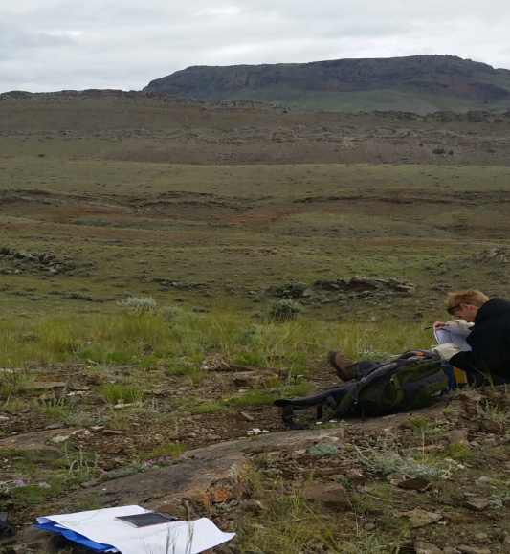

Figure 1 Movement of the Dinwoody Formation to the east because of the Ziegler thrust fault

Figure 2 Double Dinwoody structure ocuuring from Ziegler thrust faulting

Figure 3 East side of Sandy Hollow anticline showing the upward sequence of Dinwoody (closest layer next to map on the ground) to the Flood Member